# DESIGN

# INTODUCTION

Design is the most important part of any software development process. It helps to client to understand the system in easy and also it helps the developer to develop and understand the needs of the software. Finishing the analysis part, we have gathered all the information required in software now it time to design. In the part of analysis, we have made the logical part of the system and in designing part we make it to the physical part of the system. in this part we will draw the input, output, schema, database and dataflow of the system.

The very first step I have taken in process of designing is SDLC (software design life cycle) which will help on solving the needs of the SRS focusing on verifying the problem solution. I have used the waterfall methodology to reach the goal.

# Methodology

# TYPES OF DESIGN

In the designing phase three types of design level has been used to complete this process and they are:

* **Architectural Design**

In this design part product of the system will be recognized as a framework with various parts relating with each other.

* **High-level Design**

In the high-level design it mainly tries to deep on the system with every component which can be used in the form of modules.

* **Detailed Design**

It classifies the coherent construction of every module of the system and also the interface which speak through distinct module while resolve into the framework of the system.

# DYNAMIC MODELLING

# Class diagram

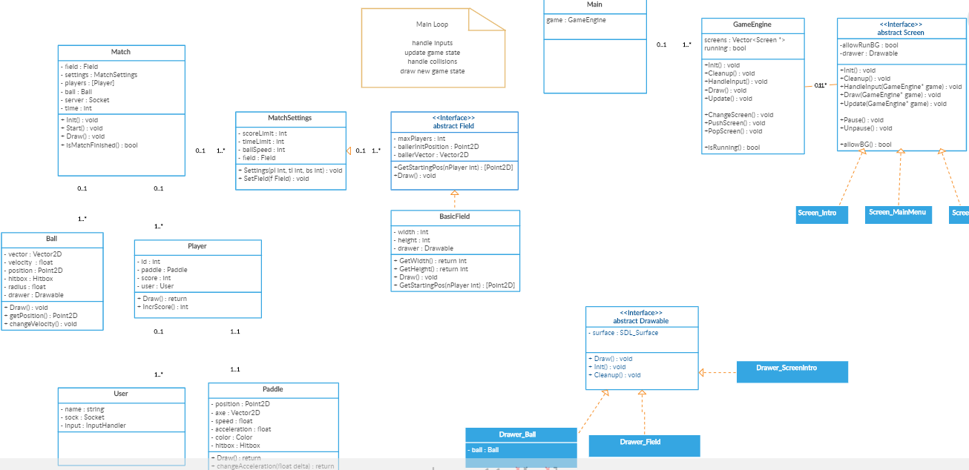

Figure 1 final class diagram

# ACTIVITY DIAGRAM

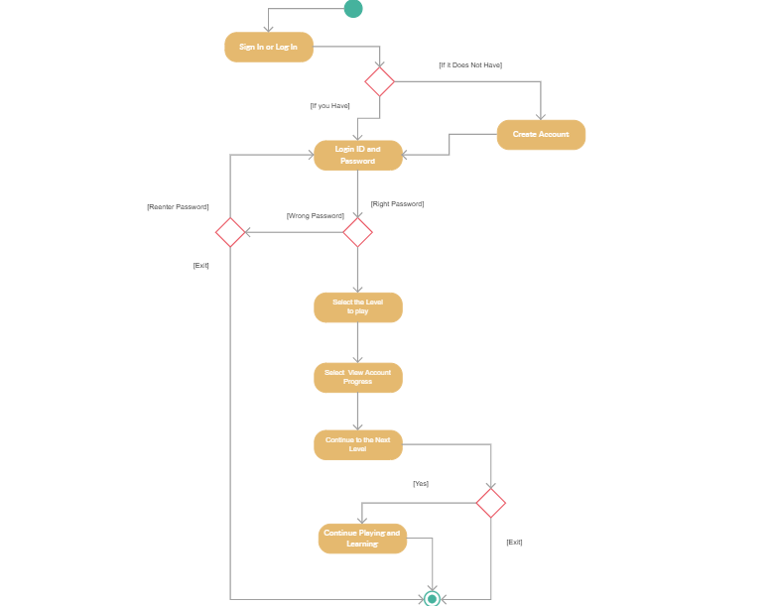

Figure 2 activity diagram of ping pong

# SEQUENCE DIAGRAM

Sequence diagram plays a vital role in UML. It describes or shows us the object collaboration and also it helps us to define event sequence between object for a certain outcome in a system. it helps us in our project by relating to analysis, design and documentation of the system.

Sequence diagram has basically also called as a timing diagram, event diagram and event scenario.

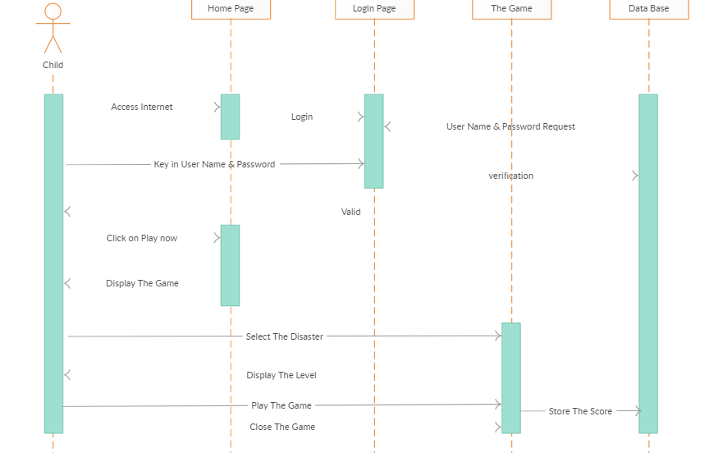

Figure 3 sequence diagram

In the above figure it shows us that the details of registration are send by the user and then the system will check the data whether it is validated or not. If the user data will be valid then the it will be sent into the database of the system after than the user will be registered into the system or else if the data will not valid than the system will generate the message as invalid data. The login process is also as same as registration. The user which is already register will play the game, select their level, select the bat as their score increases and also, they can save their game process and scores and see their score and compared with other players. After than user will logout of the game if user want and make it to the main page.

# CONTROL FLOW DIAGRAM

Control flow diagram gives us the idea about how the system will works in a detailed way so that developers will understand easily.

# DATA FLOW DIAGRAM

DFD is also known as data flow diagram which are used to represent the data flow in graphically way. it explains how the process will involve in a system for transferring of data from the input to file storage and generate the report. It can be divided into two parts they are logical and physical. Logical describes the flow of data through the system and physical describes the implementation of logical data in the system.

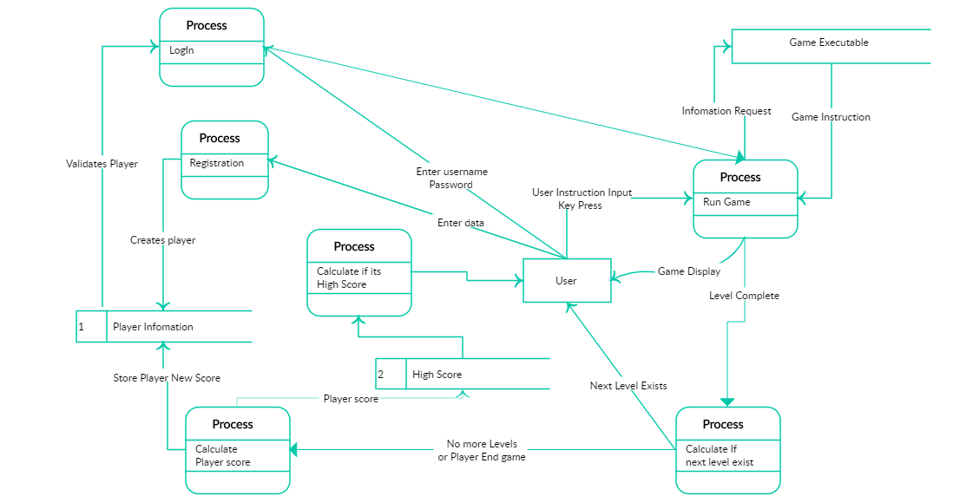

Figure 4 DFD diagram of ping pong

Players have to register to play this game so user have to give the right information to the system after register players can log in to their account and they can run the game. In above figure for login players have to give correct username and password to enter into the game. In the above figure players can select the level of the game and see their score after finishing the game and compare the score with other and also save the score it into data base. If the more level does not exist than players can exit the game or logout. Game instruction also have been provided to player where players can know how to play the game.

I have used the DFD diagram because of:

* Easy to understand.
* It gives explanation of the system to the users.
* Also helps us to understand logic of the system.

# DATABASE MODELLING

# DATA DICTIONARY

Data dictionary is a type of file which contains database metadata. It consists of data like the owner of data, relationship of data between other objects and so on. In my project it consists of player information and the score of the player which help to compare with another player score.

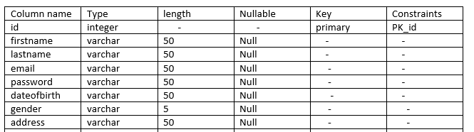

Figure 5 user data dictionary

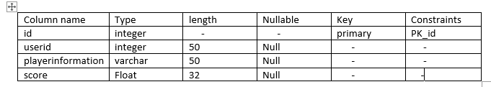

Figure 6 score and player information

# ER Diagram

ER Diagram stands for entity relation diagram which is a type of structural diagram used for database design. It consists of different symbols and connectors which shows us the interrelationship between entities.

The benefits of ER diagram are as follows:

It is easy to understand because of design in easy way everyone will easily understand ER diagram easily.

Due to its High flexibility user can easily create the relationship between entities.

Due to clear heading and titles user can easily understand the relationship between entities.

Due to visual representation user will determine the data flow of the system and also how the system will work.

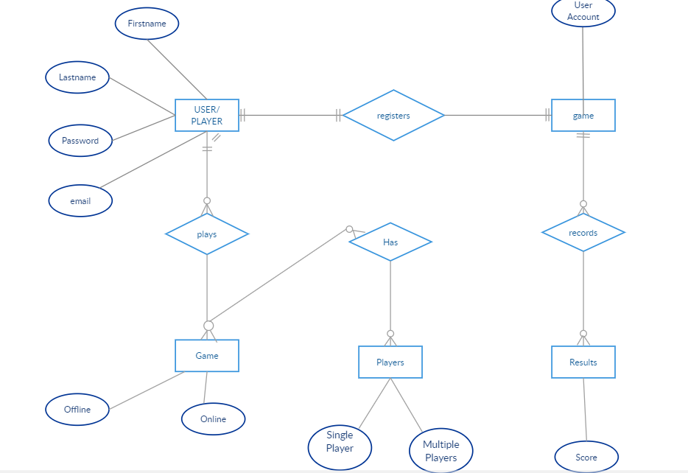

Figure 7 ER diagram of ping pong

# UI MODELLING

UI means User Interface where the interaction between human and computer is happened and networking with devices. It plays a vital role in the world of application because it helps in the usability of application in easy and understandable way. it is a prototype how the project will be visible after finishing of the project.

There are numerous of point which built a best UI and some of them are as follows which I have included in my UI too are:

Icons will be written in standard and clearly way so everyone will see and understand easily.

Attractive colors should used so that UI should look attractive and attract people.

Don’t put everything on same UI which makes too dirty UI should be clean.

Mainly focus on the main function of the system and clearly labeled it.

Logo of the brand should be well maintained.

My UI modelling for my system is below:

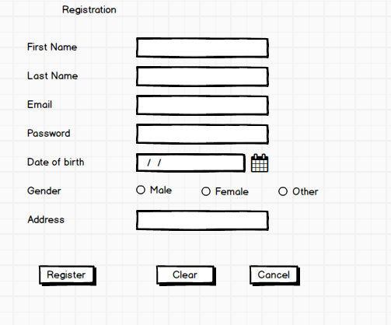

Figure 8 registration UI

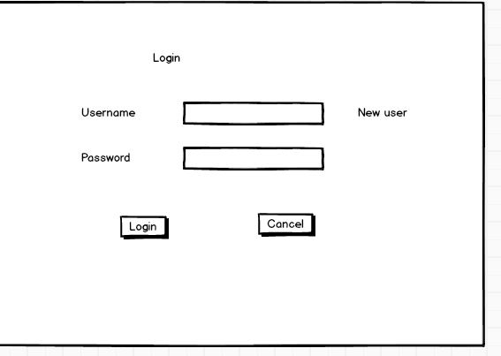

Figure 9 login UI